**EXP7: DESIGN AN PROGRAMMABLE DIGITAL DATA DISPLAY SYSTEM**

**CIRCUIT DIAGRAM:** 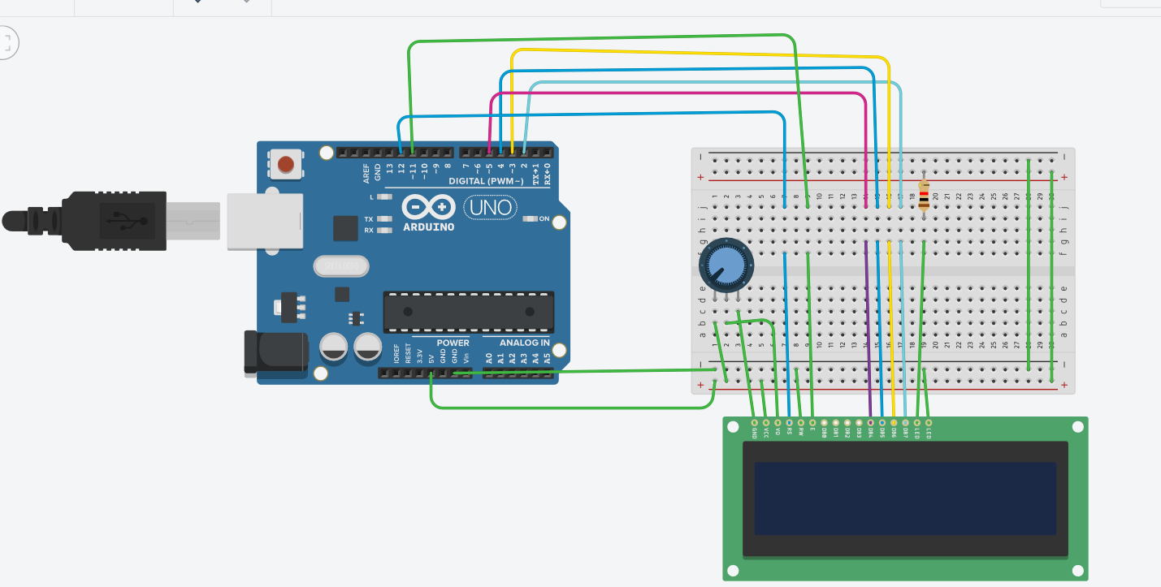

**THEORY :**

**CONCEPT USED :** In this experiment first we used the basics of electronics in connecting the breadboard connections and the concept of the connections of the Arduino with thelcd.

The concept of coding of the Arduino for the lcd is also used.

**LEARNING AND OBSERVATIONS**:

Through this experiment we can learn the use and the applications of Arduino and the programming for the digital display.

We can also learn the coding for the Arduino for the lcdfrom this experiment .

**PROBLEMS AND TROUBLESHOOTING :**

We mainly face problems in making the properconnections in the breadboard and the connections oflcdwith the Arduino.

We also face problem in making connections of lcd and breadboard because there will be many connections to be made.

And the code of the Arduinofor connecting lcdshould be given properly.

**PRECAUTIONS :**

One should be concentrated while making the connections of breadboard and Arduino with thelcd.

And also the code of Arduino should be checked twice.

The use of extra connecting wires should be decreased.

**LEARNING OUTCOMES :**

We can Learn the a real life application from this experimentlike how an lcd works on programming like in case of calculator.

We can also learn the coding for the Arduinofor the lcd.